
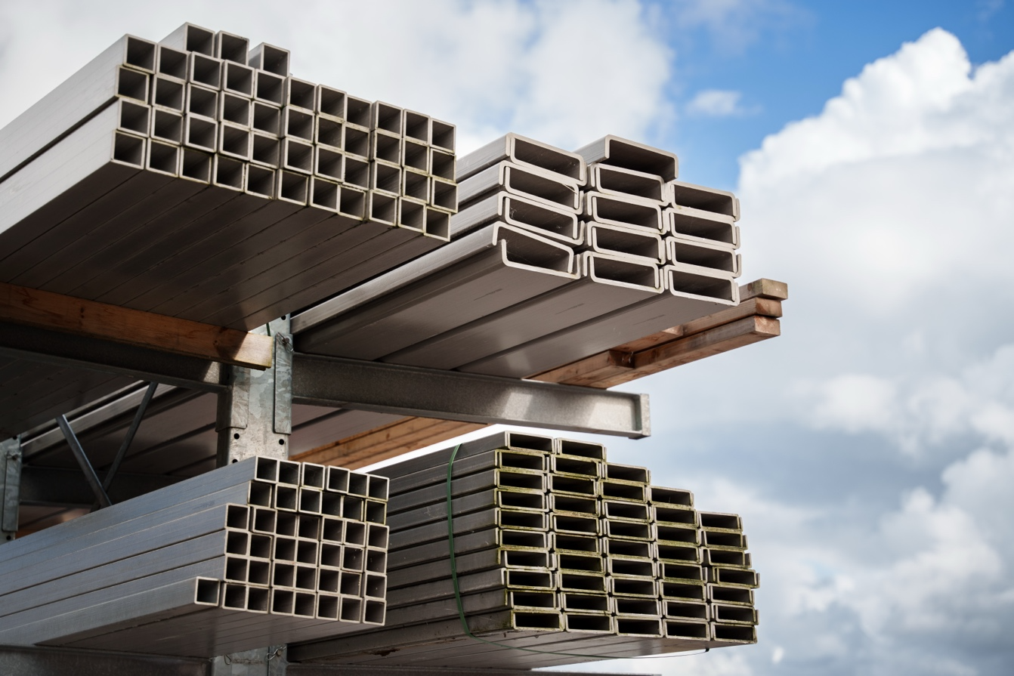
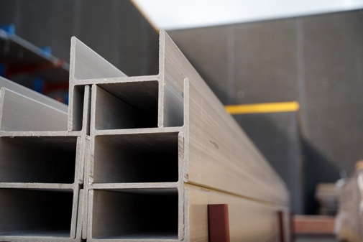
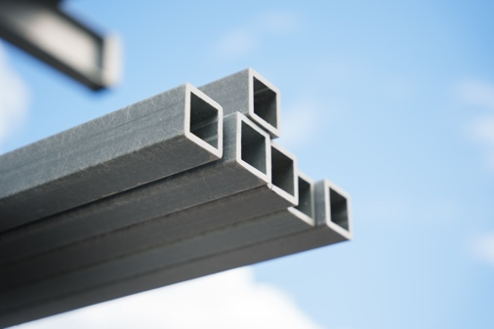
No corrosion
Fiberglass is inherently corrosion-resistant, allowing it to retain strength and durability even in harsh environments.

Easy to use
The lightweight and corrosion-resistant nature of fiberglass make it easy to transport, cut on-site, and install.
High strength
Fiberglass offers high strength while remaining lightweight, making it a practical choice for various load-bearing applications.
No corrosion
Fiberglass is inherently corrosion-resistant, allowing it to retain strength and durability even in harsh environments.
Easy to use
The lightweight and corrosion-resistant nature of fiberglass make it easy to transport, cut on-site, and install.
Strong and long lasting
Fiberglass structural profiles
Glassfiber Produkter AS offers a diverse range of high-quality fiberglass structural profiles, ideal for a wide variety of applications requiring durability and strength.
Our profiles are designed to meet the following industry standards for quality and safety:
- EN 13706 – European standard for structural profiles
- EN 14122 – European standard for access structures
- Eurocomp design guide
We maintain a large inventory of 6-meter full-length profiles, which can be cut to your specified dimensions.

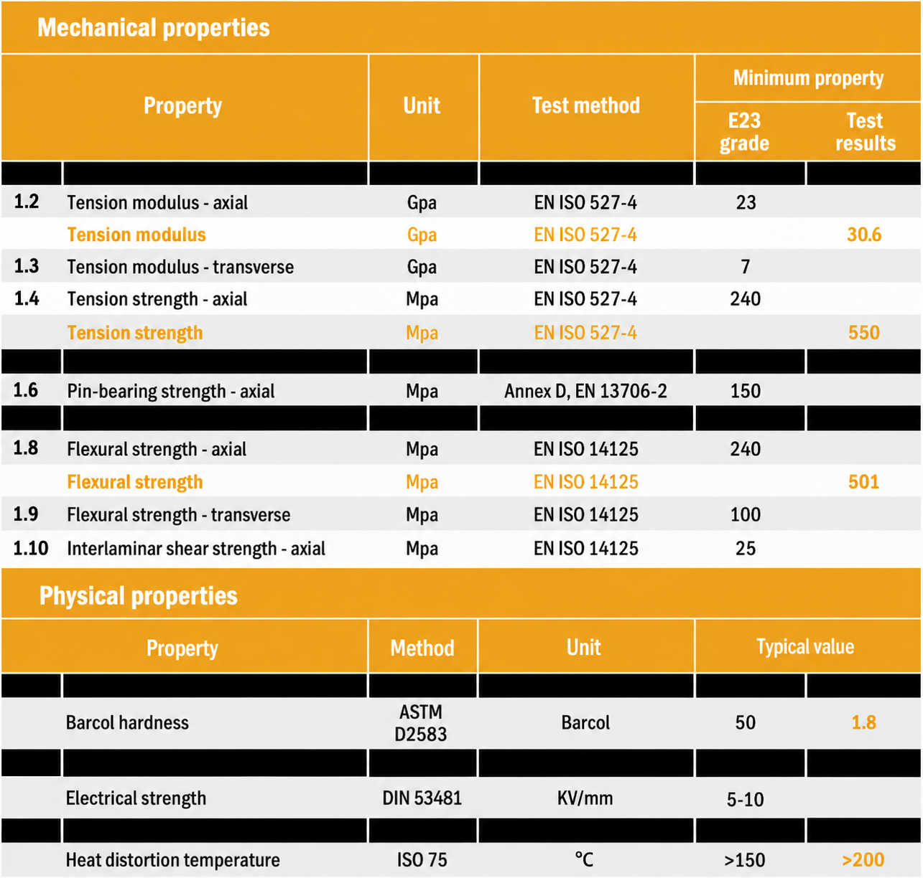
Mechanical properties
Fiberglass structural profiles from Glassfiber Produkter AS comply with strict performance and quality standards.
Refer to the table below for the minimum mechanical properties.

